Graffiti-Style Name Design
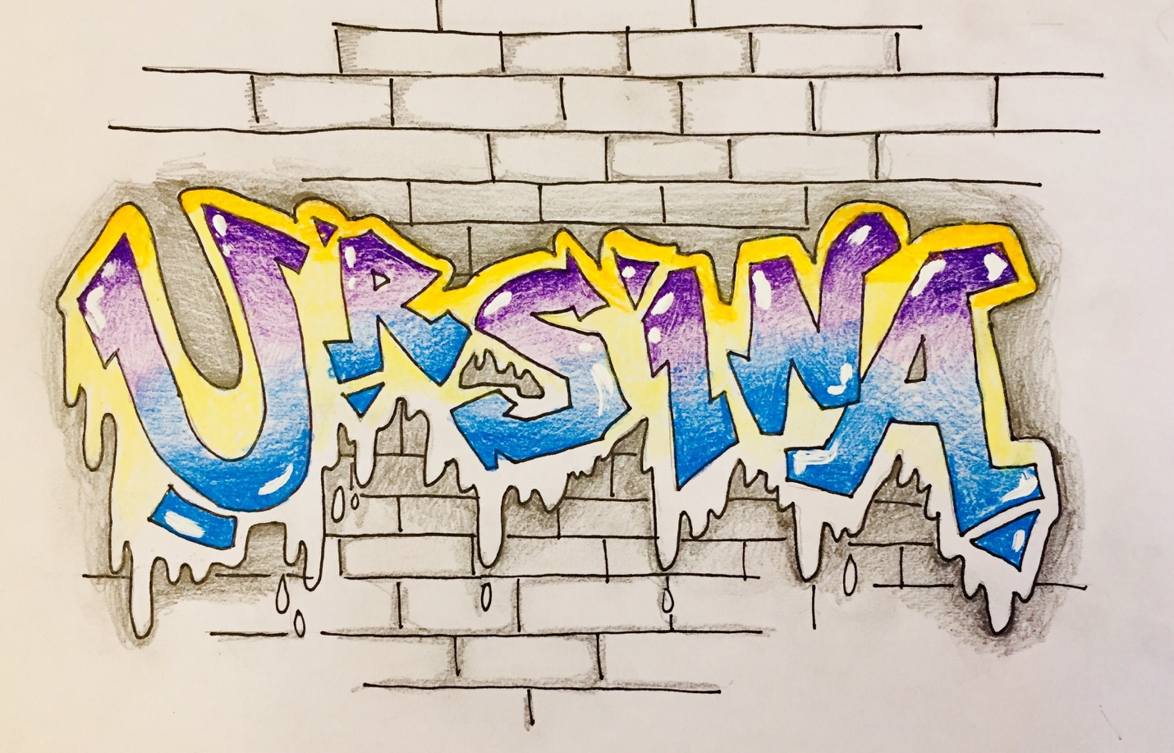

First, watch the video that this lesson is based on:
https://www.artsonia.com/teachers/ideas/entry.asp?id=12

GRAFFITI STYLE NAME DESIGN
STEP 1
- Hold your paper horizontally.
- LIGHTLY sketch your first or last name.
- Feel free to jumble the placement of your letters in a funky way, but be sure it’s still easy to read from left to right!
- BE SURE TO LEAVE MORE SPACE THAN USUAL BETWEEN EACH LETTER.

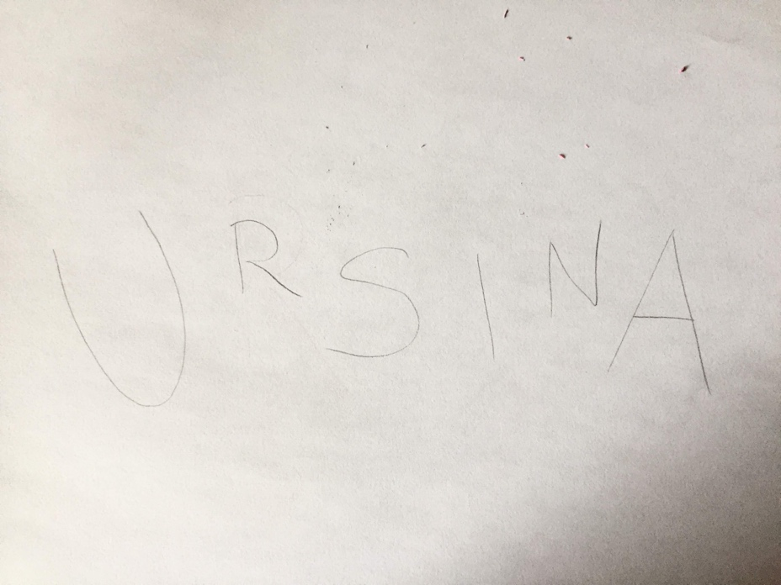

STEP 2
Use some of the suggestions from the video to add “extras” to your letters:
- Make some curved parts angular.
- Add extensions or “arrow points” to ends of letters.
- Add some extra lines/marks around the edges of some letters
THIS STEP IS THE MOST IMPORTANT WHEN IT COMES
TO GIVING YOUR LETTERS THAT “GRAFFITI” FEEL!

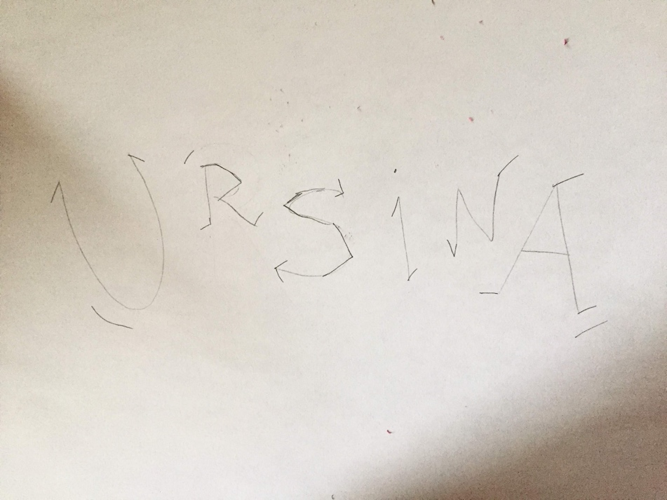

STEP 3
- Use your pencil to “thicken” each letter into a bubble-style letter.
- Also do this with any lines you drew at the tips/edges of your letters.
- It’s OK if your letters touch --- just create overlapping as necessary. (See how my “N” overlaps my “A” just a bit?)

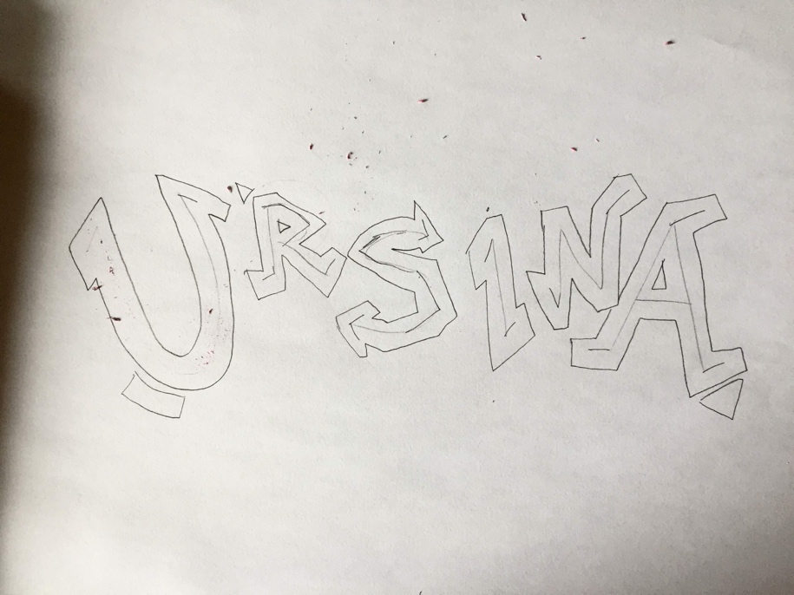

STEP 4
Now, Use a Sharpie, (or a thin black marker) to outline these new letters and ERASE the guide letters inside!

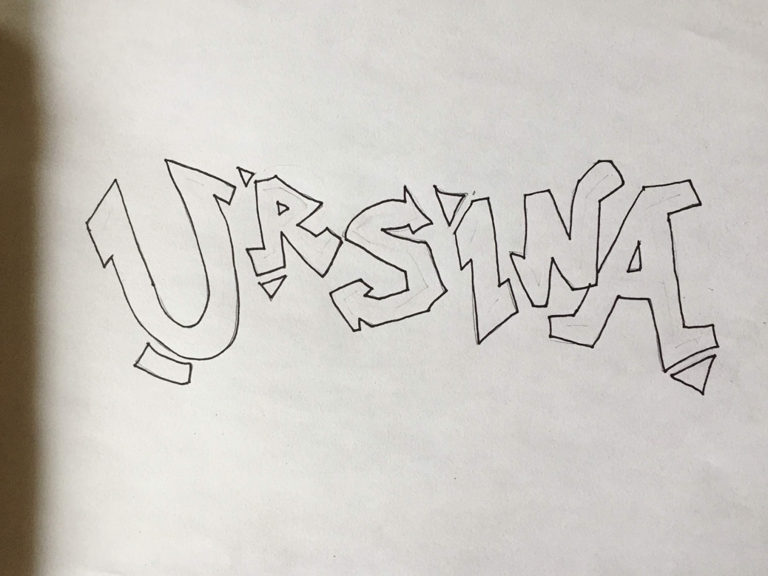

STEP 5
- Create a dripping paint effect: On the tops of your letters, it’s just a “bubble” shape that goes around the tops. On the BOTTOM is where you can get creative and play with the length of your drip shapes.
- You can even add some “single drips”.
- Do this in pencil first, THEN pen!

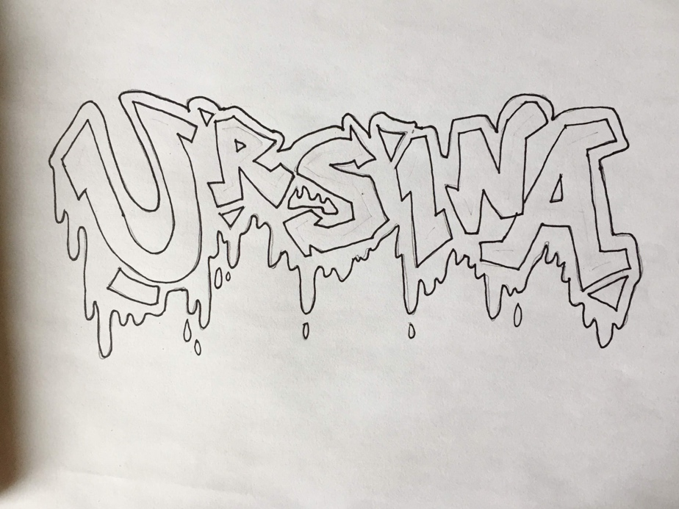

STEP 6
- Use a pencil and a ruler to draw horizontal parallel lines to start a brick wall behind your letters, above AND below. (This can get tricky on the bottom where you will have to lift your pencil a lot to skip over the drip effect!)

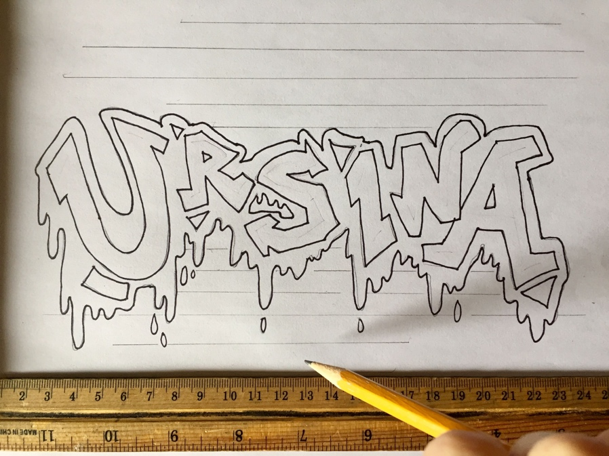

STEP 7:
- Use alternating vertical lines to create the individual bricks and Sharpie over your wall when you’re happy with it.
- You can make your wall fill the whole background, OR do what I did: I made it kind of randomly fade out!

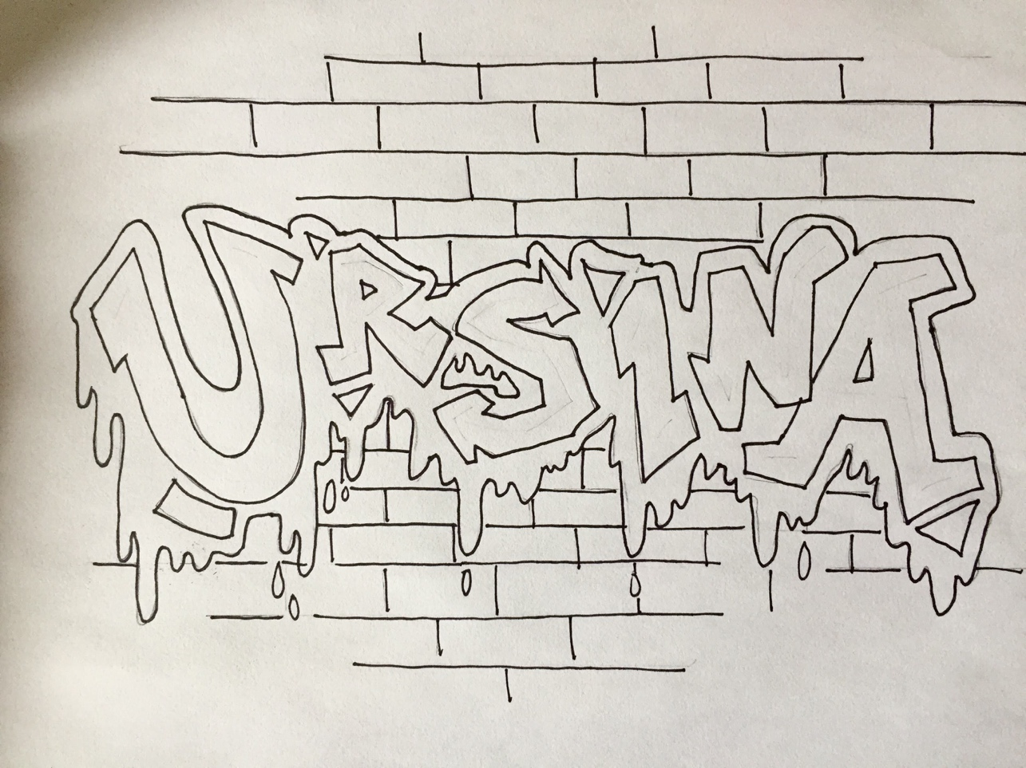

Continue on for coloring instructions…

STEP 8:
- Use TWO color pencils for your letters:
- One color fades from the top down, the other color fades from the bottom up.
- You can leave the center of your letters white, OR allow the two colors to overlap a bit in the middle.

First I faded with purple from the top down…
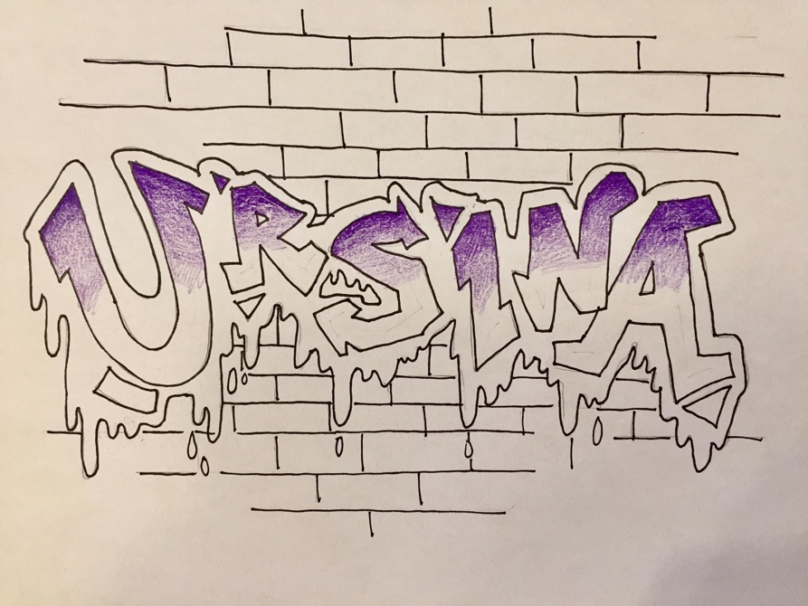

Then I faded with blue from the bottom of the letters up…
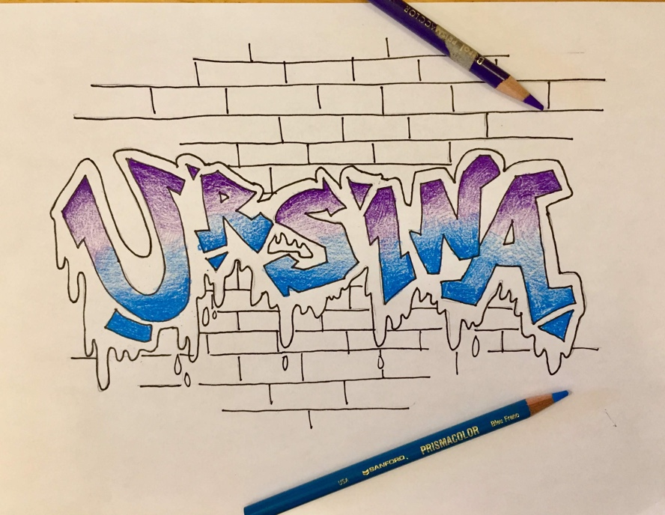

Tips for successful blending:
- Press harder where you want your color darker, and lighter as you start to fade.
- Layer your color pencil work in multiple directions for the smoothest look.
- Keeping your pencils sharp will make your work look neat and more in control!

STEP 9:
Next, use a regular pencil to shade around your “drip border”.
- Press Harder close to the letters, and lighter as you move away from the letters.
- It is helpful to use your finger to soften and blend this shading work!
- Also, add a little emphasis to the edges and corners of your bricks--- it will help them look more 3D!
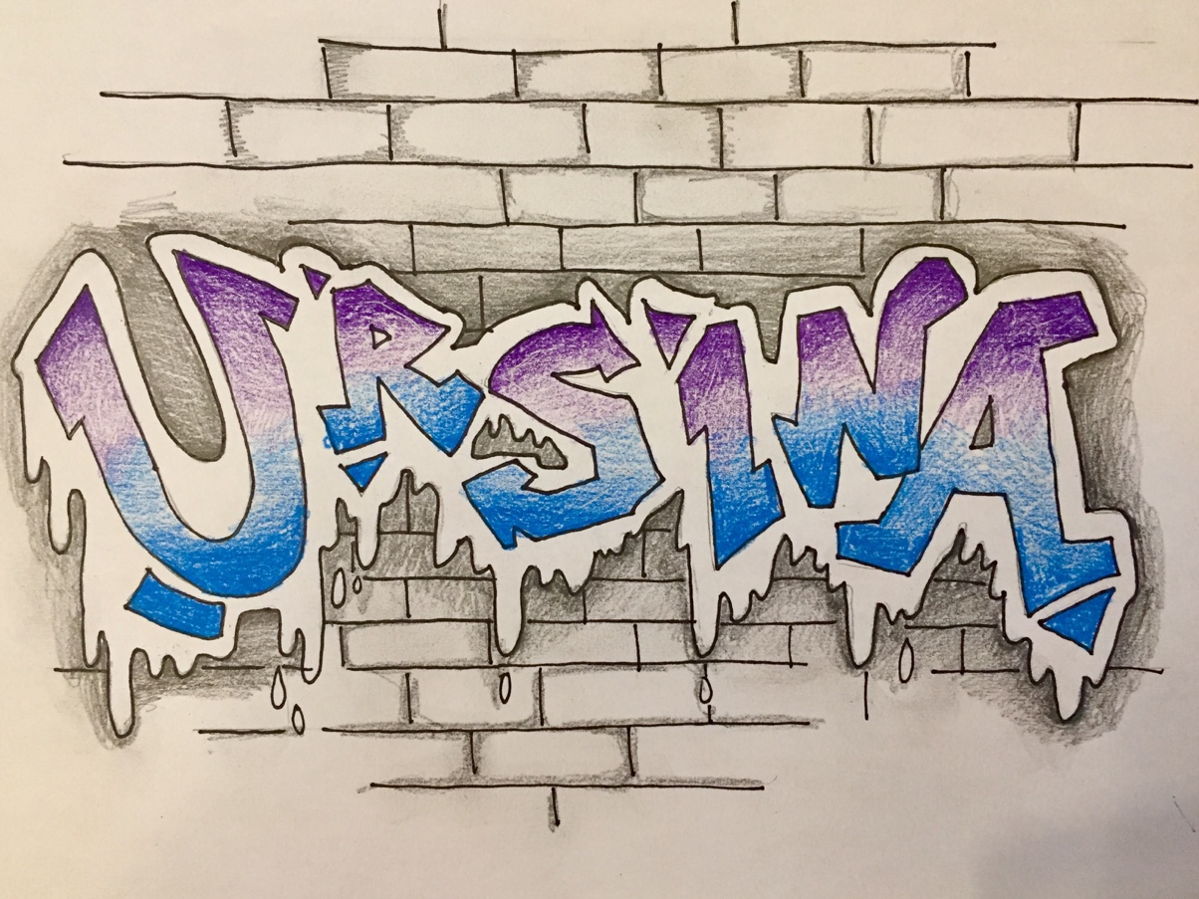

Detail of Brick work:

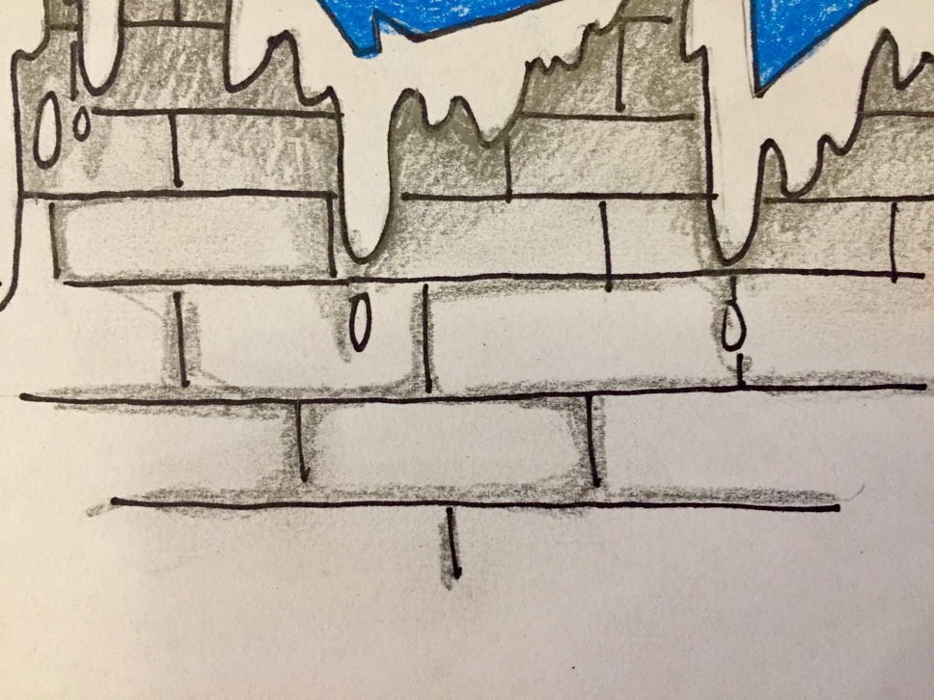

BONUS FEATURES!
You can stop where you are, or consider trying the following bonus steps:

- Add some color to your “drip border”. I blended yellow from the top down, then went over the very top edge of the drip border with a light orange.
- If you have white-out, you can draw some reflective elements on your letters to give them “shine”.

Crop the photo and play with color and contrast before uploading it!

Posting your art:
Ms. Amsler’s Bb page Content 7-Red Online Bulletin Board Select Your Period Select “reply” to my original post and add your picture using the “insert/edit image” button.

Please have your art posted by your class period next week!

